Different Gemini API Replacement

I just got a mail form the Google AI studio after submitting the project that my previous API Key has been exposed as it is a rule for google that the API can not be used in public sharing platform like git.
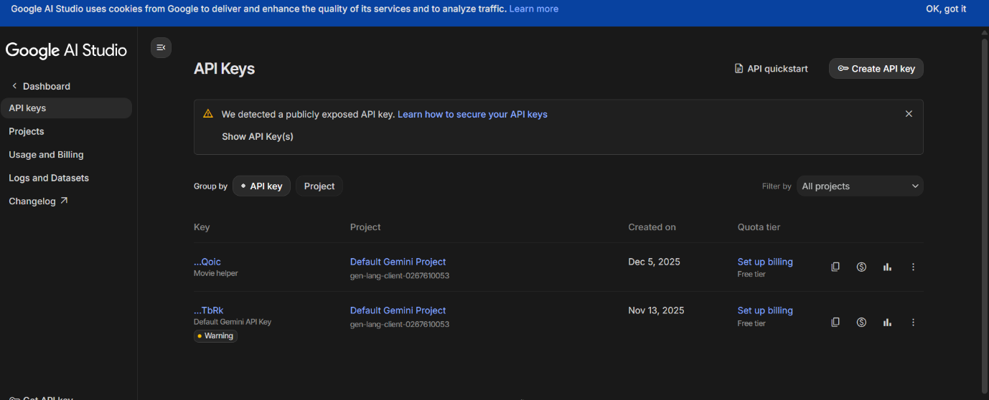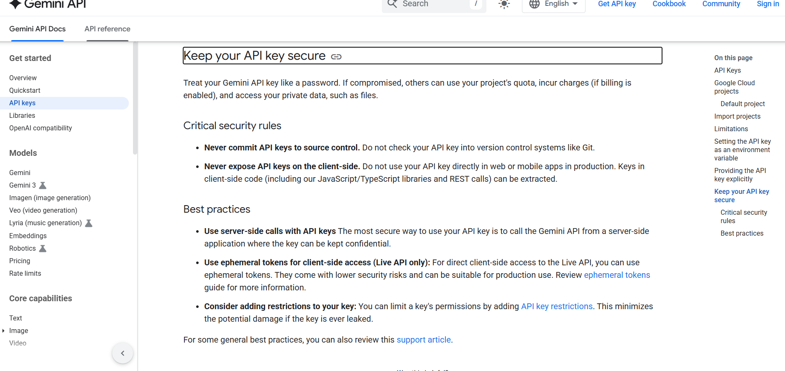
The Demo Gemini API key is intentionally given for security reasons and is not shared on GitHub. To test the project, please generate your own Gemini API key and add it locally in the secrets.toml file. The code is already prepared to work once a valid key is provided. Otherwise, please feel free to open an Issue and I’ll help you out personally.

